**E marketing portal developer guide implementation on Local server**

**Software needed**

1. WAMP server - <http://www.wampserver.com/en/>
2. CodeIgniter (Consist within the given project source code)

**Files Provided**

1. Project source code – CodeIgniter.rar
2. Database backup – sep.sql

**Steps to follow**

1. Installing WAMP server

* Watch the following video

<https://www.youtube.com/watch?v=MsMaiHqkKkQ>

1. Configuring database

* Open any web browser
* Type <http://localhost/> on the address bar
* Click the phpmyadmin link

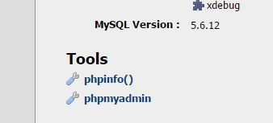

* Use default username root and default no password to login

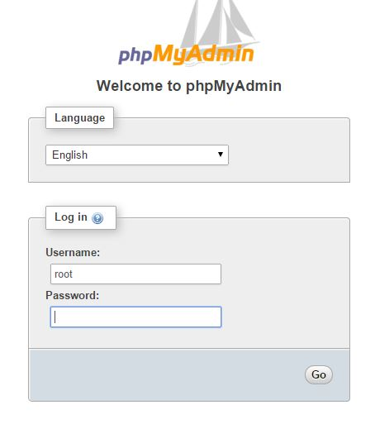

* Then a interface shown below appear

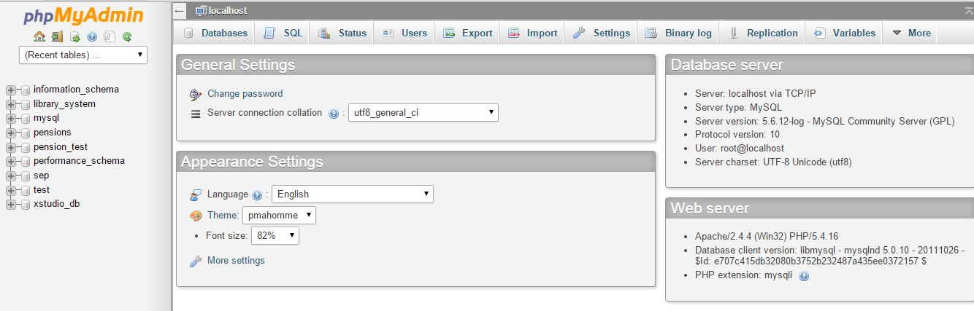

* Go to import

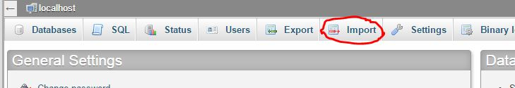

* Then select the sep.sql file provided from the Choose file and select format as SQL

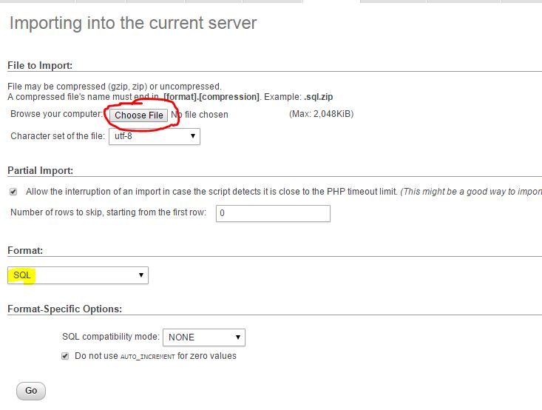

1. Configuring and Deploying site in the localhost

* Select the CodeIgniter.rar file provided with these files
* Unzip it to the **C:\wamp\www** folder and all project files must be inside **CodeIgniter** folder
* Then go to any web browser and type the following address in the address bar

<http://localhost/CodeIgniter/index.php>

* Then the e Marketing portal web site will be successfully hosted in the local WAMP server

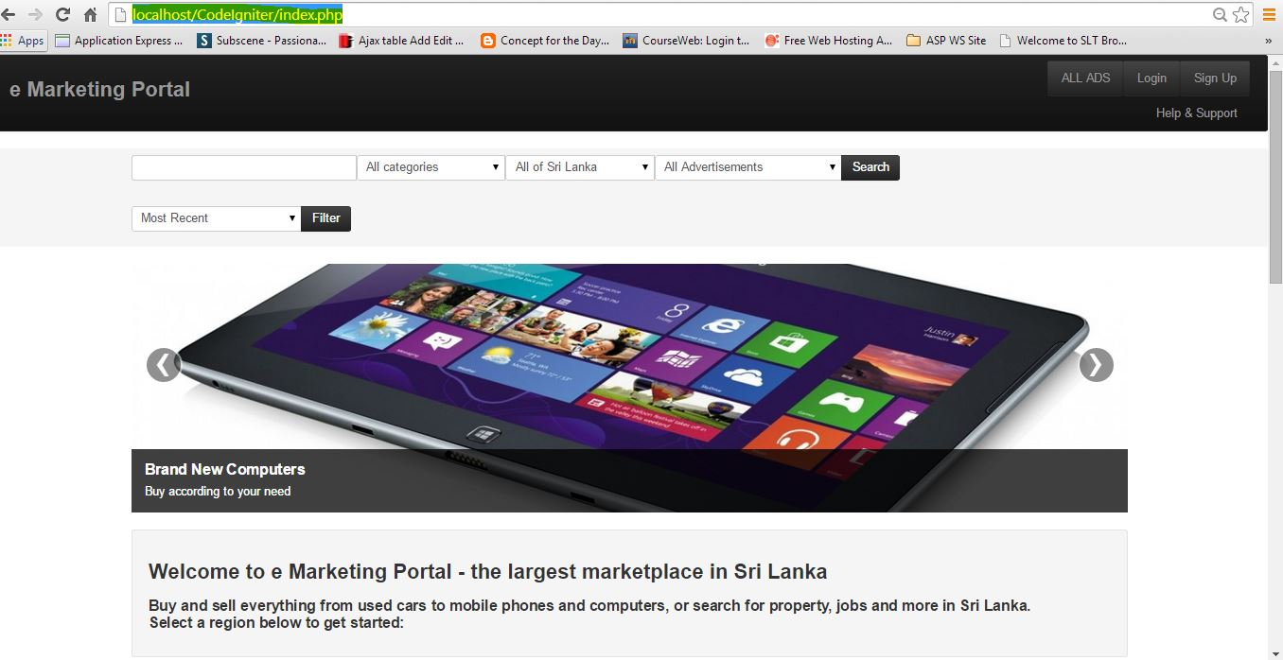

**E Marketing Portal hosted website**

<http://knbtest.site40.net/index.php>